Training Documentation
Report Builder
Purpose: To teach users to use the report builder.
Contents
Creating a Report Template 2
Running a Report 4
Advanced Options 7
Question Options 9
MS Excel Templates 10

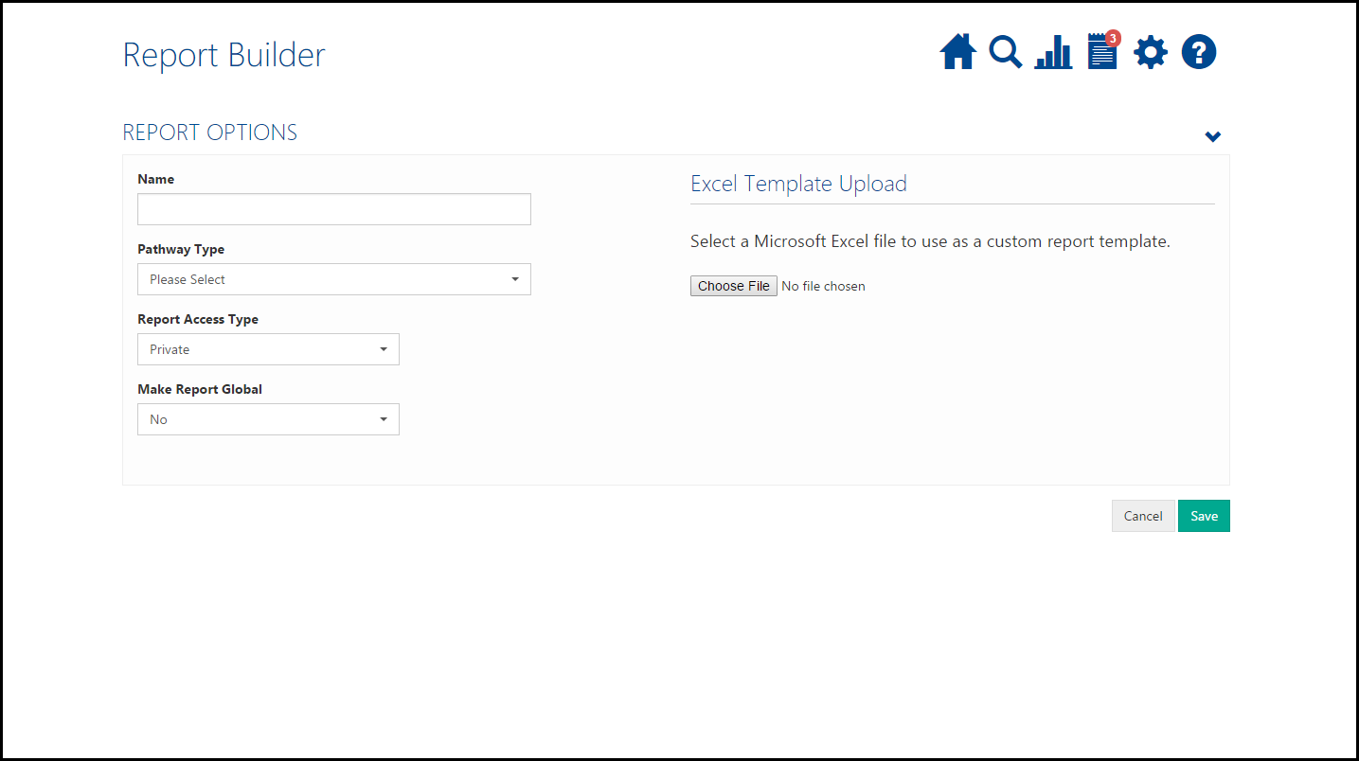
Creating a Report Template
Name – Name your report template
Pathway type – Choose which pathway to run the report on. You cannot run reports across more than one pathway. Once selected, it shows the forms available in that pathway.
Report Access Type – It only affects Registry and Enterprise users. Choose to make the report Private or Public. When made public, all users within your organisation can see it. If set to private, only you or delegates can see the template.
Make Report Global – It only affects Pro-ONE users. Clicking Yes will allow users who work outside your organisation to see this template.

After selecting a pathway type, these options will appear.
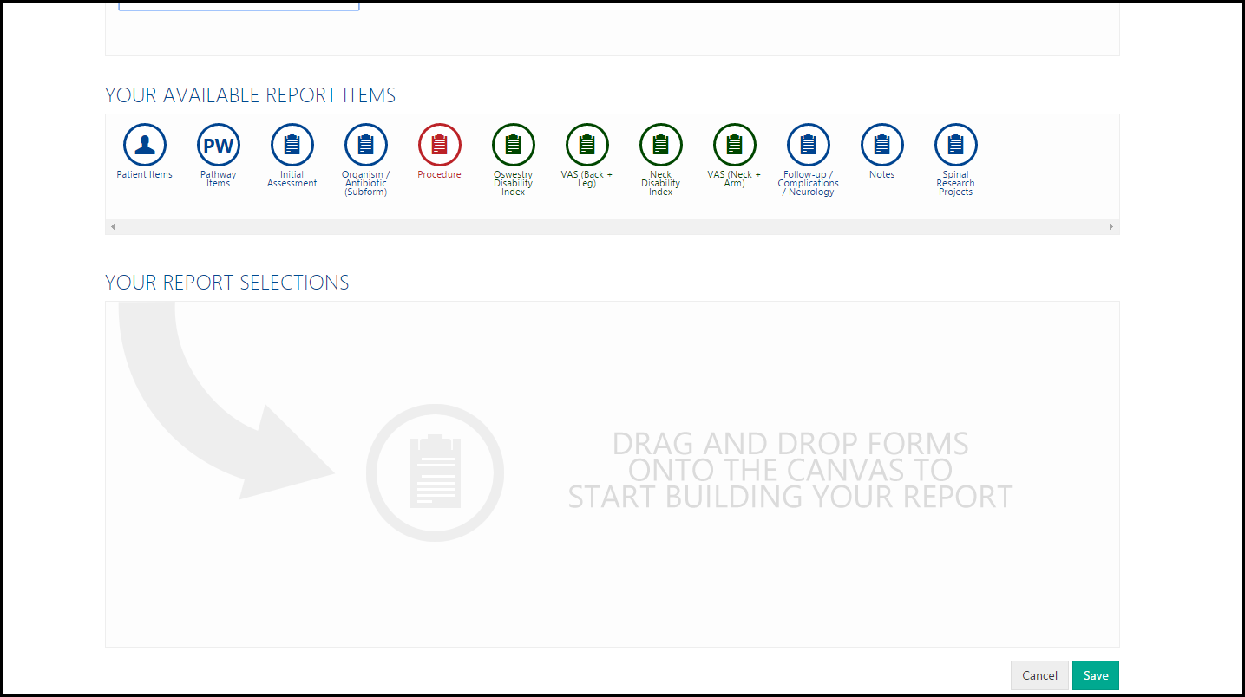
In Blue are standard forms. In Red are procedure forms. In Green are forms with score components.
Click and drag the icons containing the report items to the canvas below. To remove them, click the X on the right hand side.
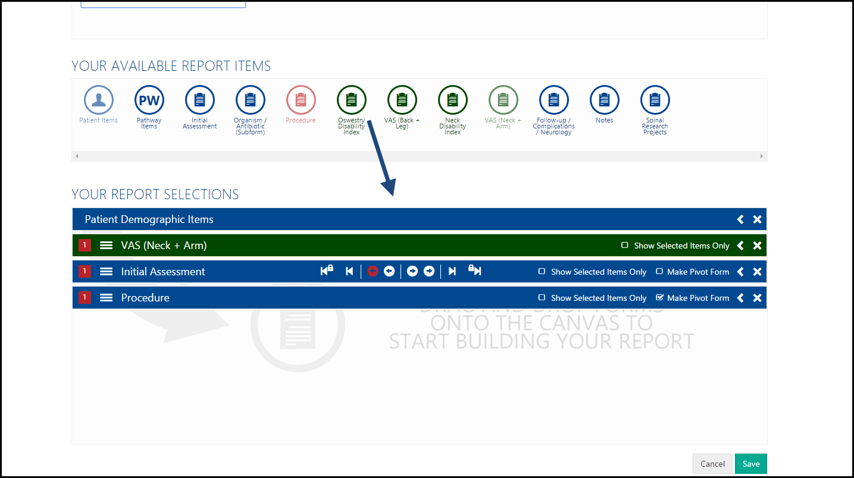

Tick the boxes of the items you would like to run the report on. Only ticked items will be shown in your report.
- Form questions have a Q symbol
- Demographic options have a person symbol
- Scores values have a green symbol
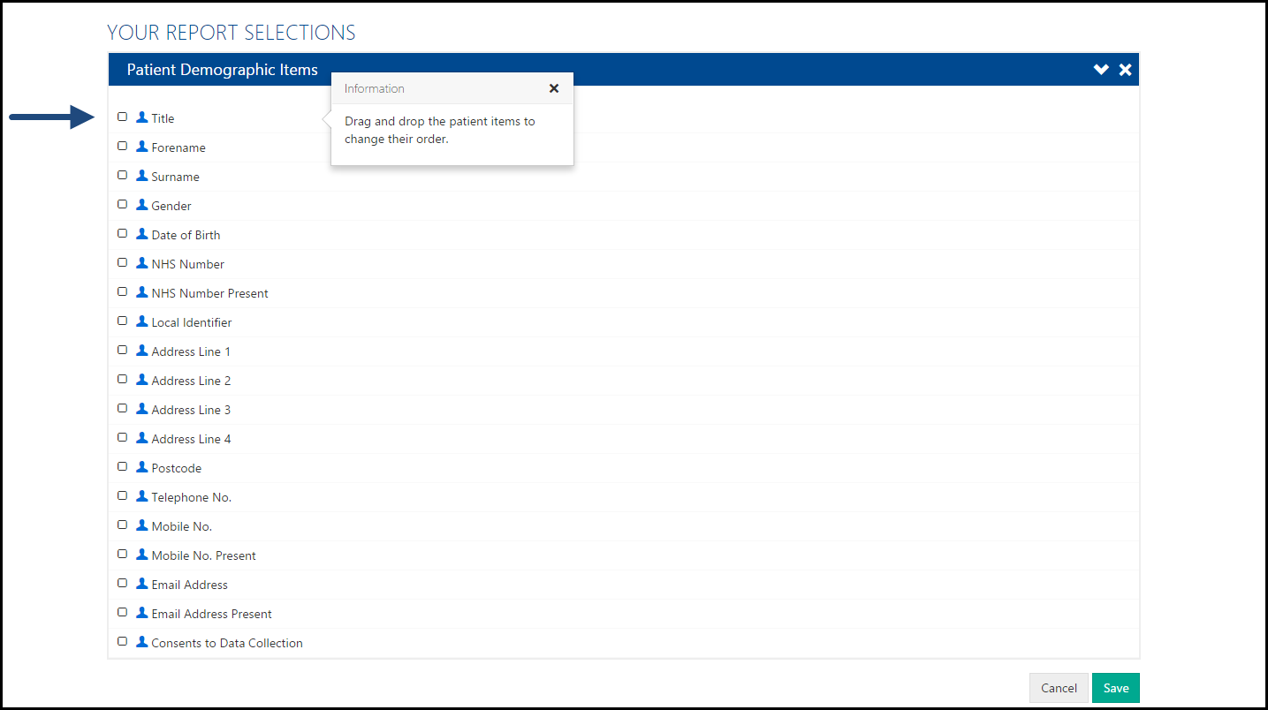
When chosen all items to report on, click Save. These items can be moved and dragged into a different order, which will match how it appears on the Excel spreadsheet.

Running a Report
Click the green arrow to run the report across a time period and group of patients. The time period relates to the pathway creation date - so any pathways created between the two dates you choose will show in the report.
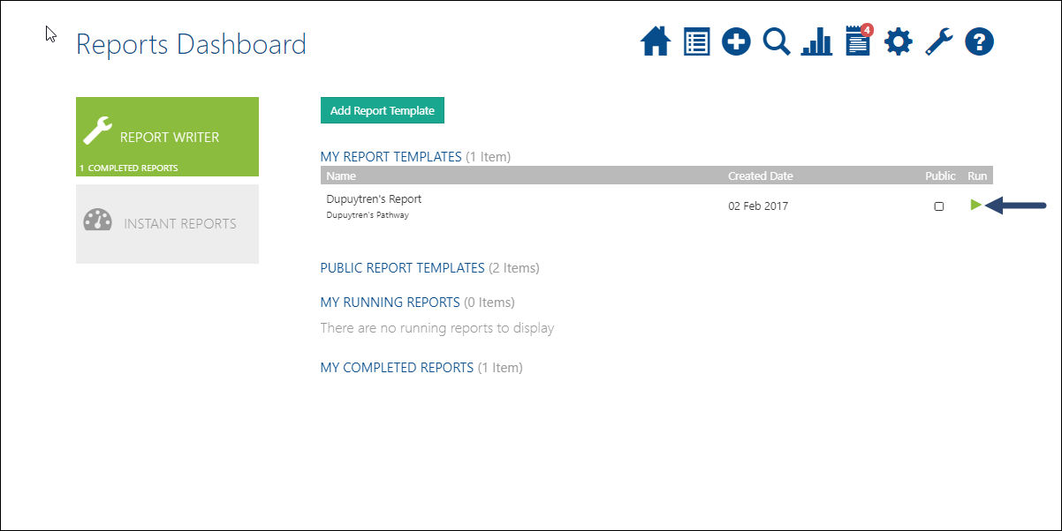

Choose which patients to view, the options are:
- ‘All Patients’ - all patients under the organisation (this is only available to users with this permission)
- ‘My Patients’ - all patients you are the owner of
- ‘All Patients I Have Access To’ -all patients you are the owner of and all patients that you have explicitly been given access to
- ‘All Patients of Users I Delegate For’ - all the patients belonging to all the clinicians I am a delegate for
Click Run Report. The running form appears in the completed forms section but the spinning arrow shows it is not yet complete. Large reports may take a while to complete.
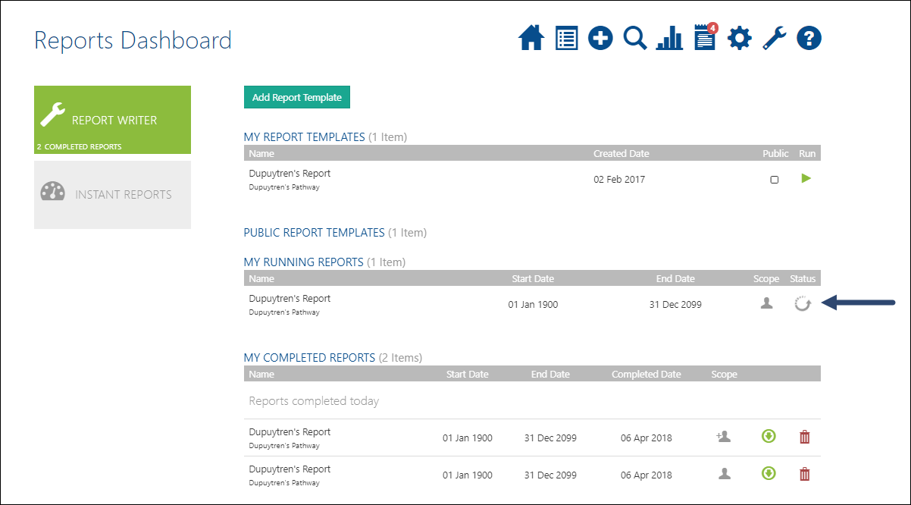
To view the data, click the green download button. Please Note: Downloading this file will save patient identifiable data to your computer’s hard drive. I am aware of my responsibility in holding such information and would like to continue. Data is automatically saved to your downloads folder regardless on if you save the spreadsheet.
Once into Excel the data can be filtered by highlighting the column headings and then selecting Data tab then Filter icon. At this point all the columns can be filtered and different responses selected to manipulate the data according to the information you are trying to obtain i.e. filtering by a type of implant or by a specific type of operation.

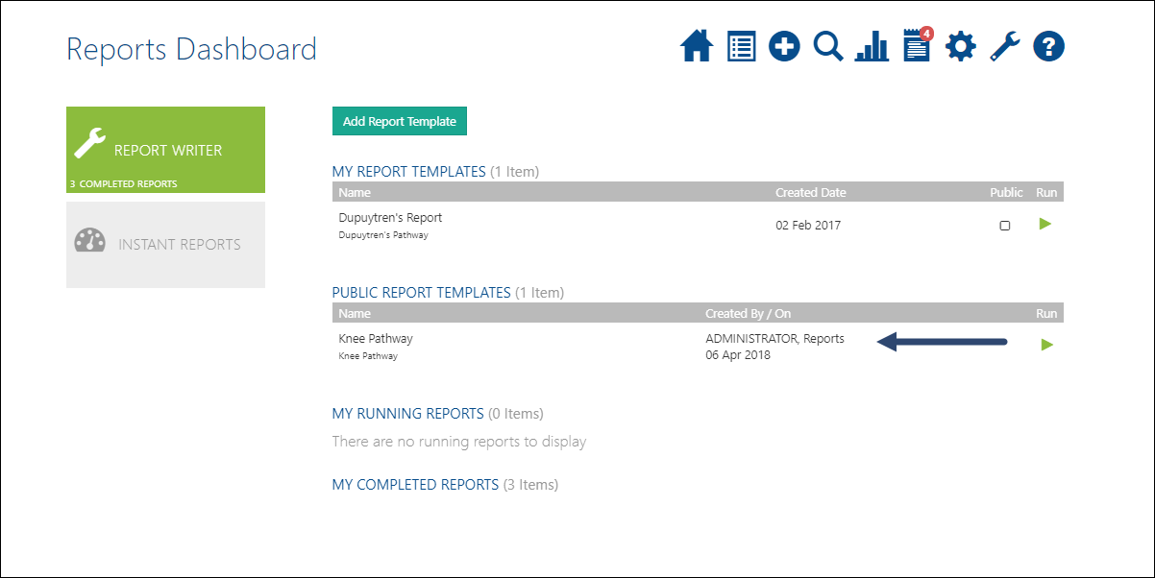
Public Report Templates are available to use. This are templates prepared by other site users or Amplitude Staff and only require running and downloading.

Advanced Options
There are several different options on some of the forms. Below is a brief description.
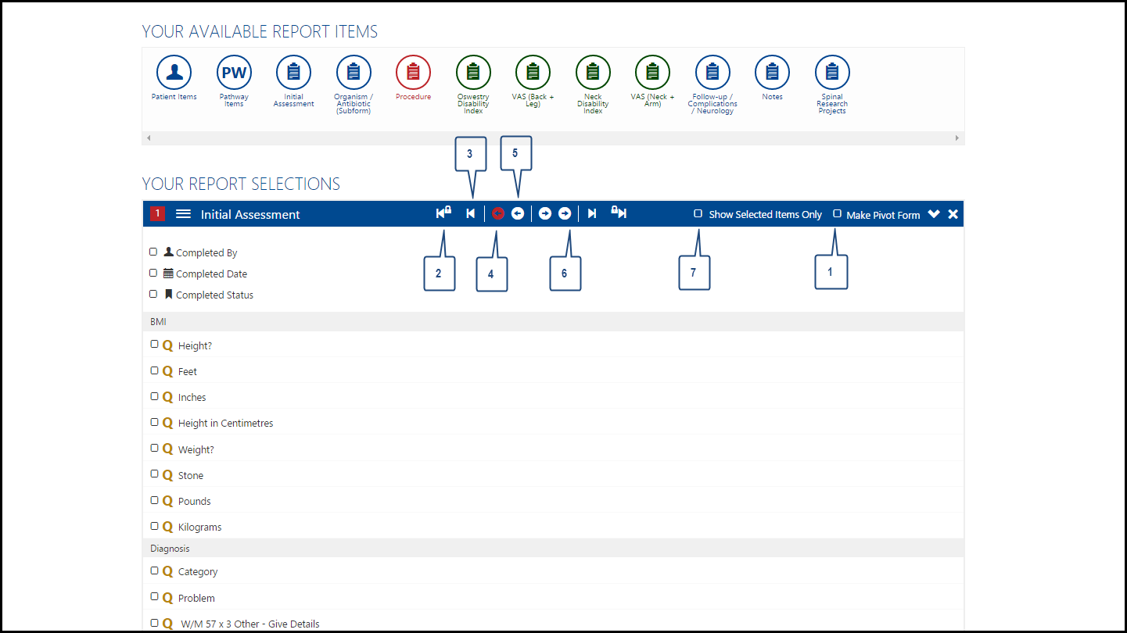
- Make a Pivot Form – A pivot form is a form which all other forms can be chosen around. For example, your patients may have five completed notes forms on their pathways and to pick the one most relevant for your report, you would like to see their results pre and post op. By making a form a pivot form, this puts a marker in at that point and allows you to separate which forms are pre-op and which are post-op. There can be more than one pivot form but only one pivot form of the same form type. For every instance of a pivot form, a new row in MS Excel is generated.
- Earliest Instance on a Pathway (Form Constrained) – This is the earliest point on the pathway that this form was given, regardless of whether the question was answered.
- Earliest Instance on a Pathway – This is the earliest point on the pathway that these questions are answered regardless of whether they appear in the same form.
- Earliest Instance Pre-Pivot – This will take the selected questions from the form that occurred furthest post -pivot.
- Latest Instance Pre-Pivot – This is the form closest to the pivot form before the pivot form was created.
- Post-Pivot options – These options are identical to their Pre-Pivot counterparts.
This diagram explains it more clearly. The centre line is shows the position of forms in relation to the pathway duration. The red pivot forms so how the forms can be chosen around this point. Without a pivot form, this limits choosing forms to only choosing the last or first item along the pathway.
Note: Score forms do not have pivot options, all instances of the selected score forms will be shown in the report.
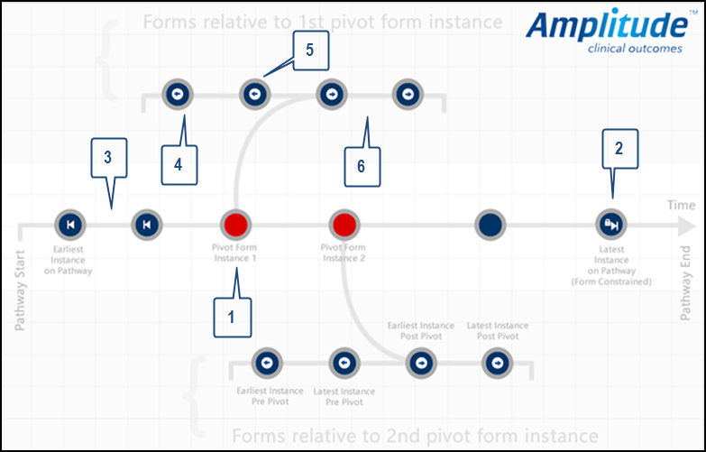
- Show Selected Items Only – When selected, only those items that have ticked in the form are viewable. Unticking this option and the full list is viewable. Items can be ordered when this is selected.
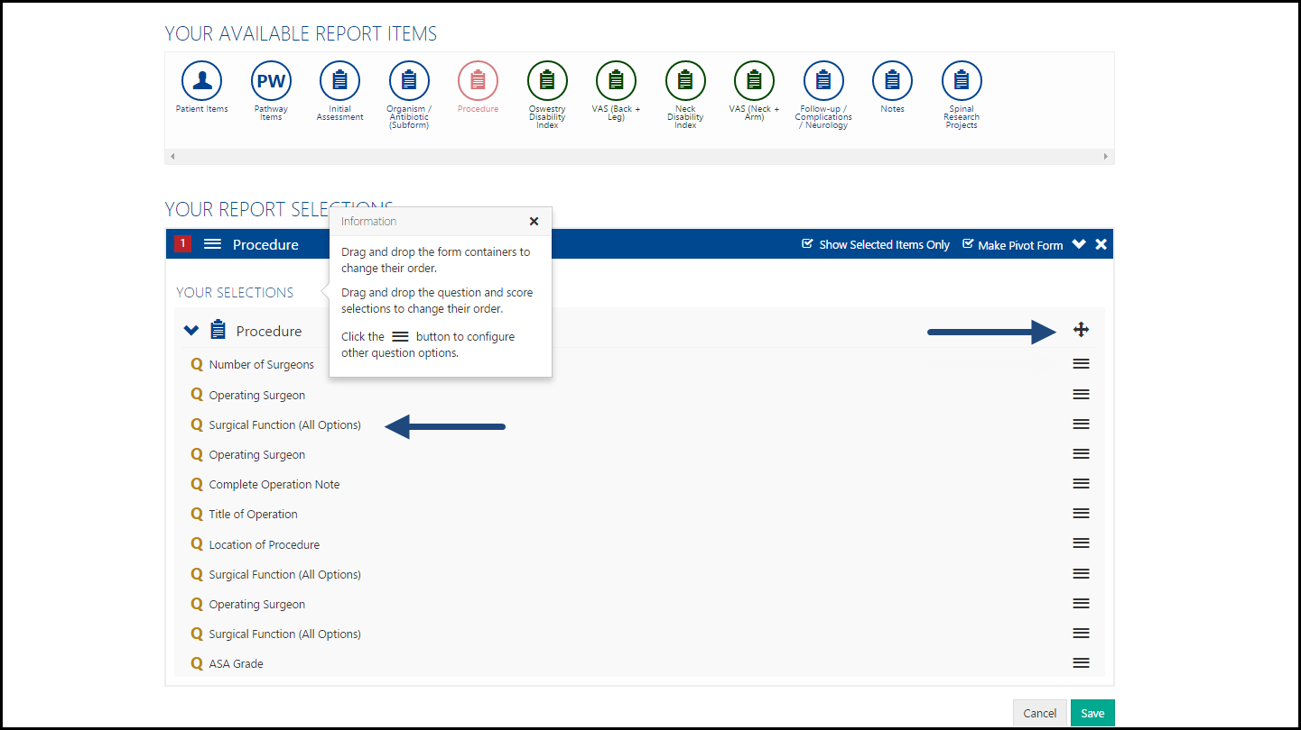

Question Options
When selected items only is chosen, left click on the three lines on the right-hand side to bring up the question options. Once done, click Apply to save these changes.

Reporting Column Name – This can be changed and in doing so, will change the name of the column in MS Excel and the name of the question in this form.
Data Type – This changes the data type in MS Excel to either a date or number depending on your selection. This would be regarded, for example, performing an auto sum function needs to be in number format.
Create Excel Named Range from distinct answers – When this is selected, it will create a new column on a new worksheet with the title you enter below. This column will contain a list of all the distance answers to the question you have selected.

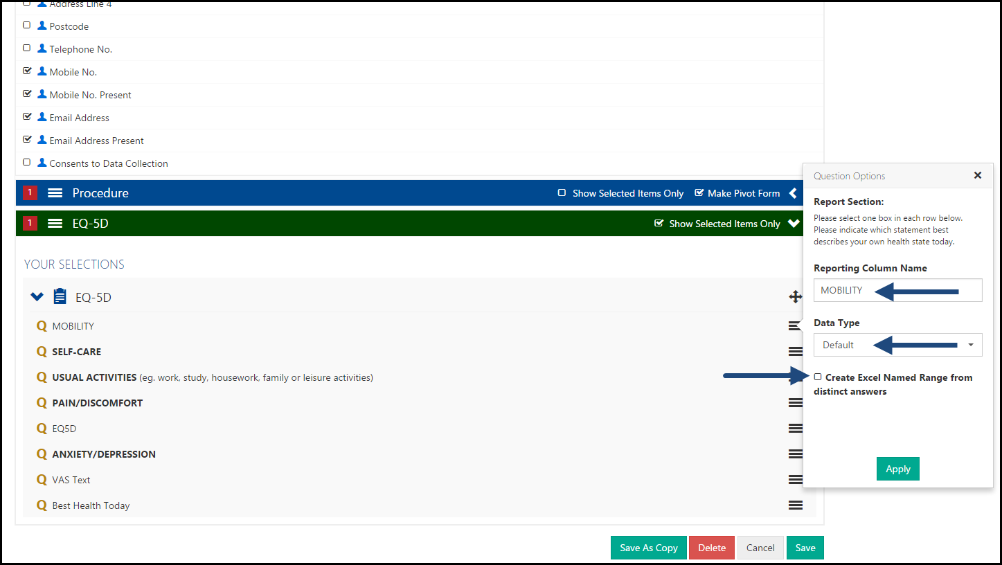

MS Excel Templates
There is the option to export information into a prepared excel spreadsheet.
Click Choose File and select which file you would like the data to appear in. Please enter the name of the worksheet on your file that you would like the data saved into. When the report is downloaded, it will automatically save to the data to this sheet on this excel file.
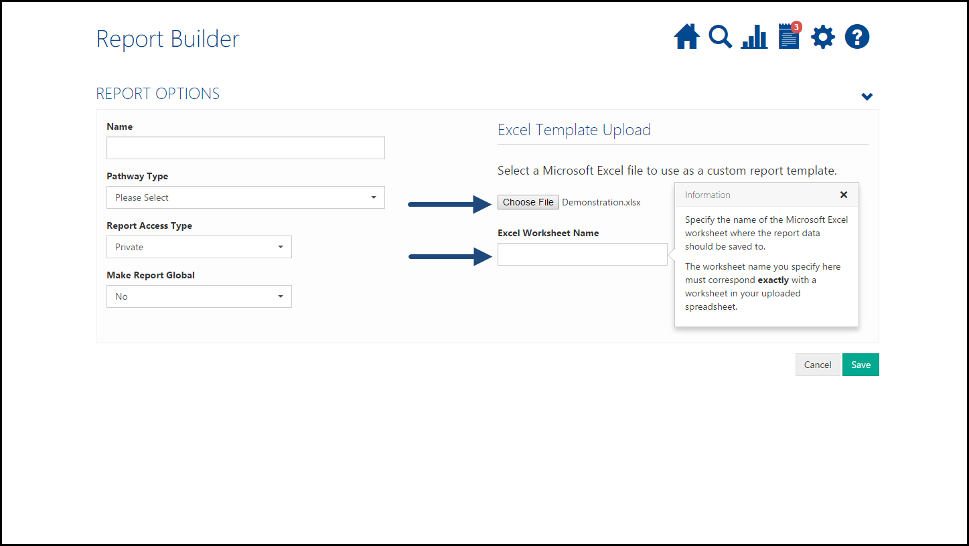

If you have any further queries, please contact the customer support desk on 0333 014 6363 or via email at customer.support@amplitude-clinical.com.

